Buildwas Parish Council
www.buildwasparishcouncil.org.uk
Chairman of the Council  Cllr L Pratt | Clerk to the Council  Mr C Furnival

10th November 2021

To all Members, Buildwas Parish Council
Copied to others for information

Dear Colleagues

NOTICE IS HEREBY GIVEN that a Full Council meeting of Buildwas Parish Council for the municipal year 2021/22 will take place on the 15th November 2021 at 7:30pm to be held at Buildwas Village Hall. Members are summoned to attend for the transaction of business on this agenda.
Yours
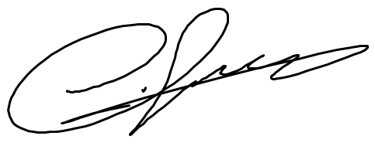
Clerk of the Council
AGENDA
- Apologies and declarations of Interest
To receive apologies and record any non-pecuniary declarations of interest in matters relating to the business to be contacted on this agenda.
- Public session
The Chairman of the Parish Council will open the meeting and allow 15 minutes for members of the public to ask questions to the Council.

- Minutes of the Full Council meeting held on 20th September 2021
Copies have been distributed to members of the Council and will be displayed on the website.

3.1 Amendment to 21/22.05 as proposed by Cllr Pratt

- Matters arising, for information, from the 20th September 2021 minutes not otherwise on the agenda
- Reports from West Mercia Police
To receive any reports from the local Safer Neighbourhoods Team
- Reports from Shropshire Council
To receive any reports from the Severn Valley County Councillor

- Reports from Parish Councillors
To receive any reports for information

- Correspondence
Items received for information, action, consultation, or decision.

8.1 Examination of the Shropshire Local Plan 2016 - 2038

- Planning
To consider any applications and to note those refused/approved since last meeting

- Arrangements for dealing with core council business outside of meeting sessions
Cllr Ling to propose agreement for dealing with such matters and members to consider

- Climate change policy
Members to consider actions to adopt a policy for climate change and subsequent actions that the parish council can take to reach its own climate change targets

- Community Led Plan
Members to receive any updates and consider actions to progress a CLP

- Finance

  - To approve the reconciliation of banking statements
  - To approve the list of payments
  - To review the latest budget review

Date of the next meeting:

17th January 2022, 7:30pm at Buildwas Village Hall

